ADDITIONAL ITEMS TO BRING WITH YOU TO CAMPUS

Fresh Haircut for Day 1
Males: Short tapered hair. No Edgar Cuts or Broccoli Hair
Females: Natural Color: Bun/ Braid/ Pony Tail

Large black backpack to carry gear – recommend separate than one for school.
Pocket Notebook (Always have it on you, starting at Orientation)

Physical Training Gear (Small brand logos are OK, please no graphics)
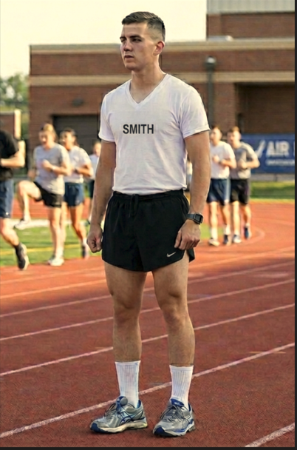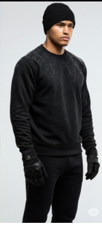

-Plain White Tee Shirts (3x) Name will be stenciled on and standardized within detachment (Do not do prior to arrival)
-Plain Black Running Shorts
-Plain Black Sweatpants/Plain Black Sweatshirt (Hoody OK)
-Running shoes
-Black Beanie
-Black Gloves
-Reusable water bottle (bring a couple)
-Wristwatch with stopwatch (Smart Watch with exercise tracking recommended to track progress, but optional)

Outdoor Winter Gear (We will be outside in cold weather)
-Warm Jacket
-Insulated hiking shoes/boots/or anything warmer than sneakers that you can walk long distances in.
-Warm socks
-Thermal underlayers (optional)- Pocket handwarmers (optional)
Alternate Duty/Classroom Uniform
-Kakhi Pants and belt with a tucked in polo shirt (Black/Blue/Gray).
-AFROTC Uniforms will be issued mid-semester
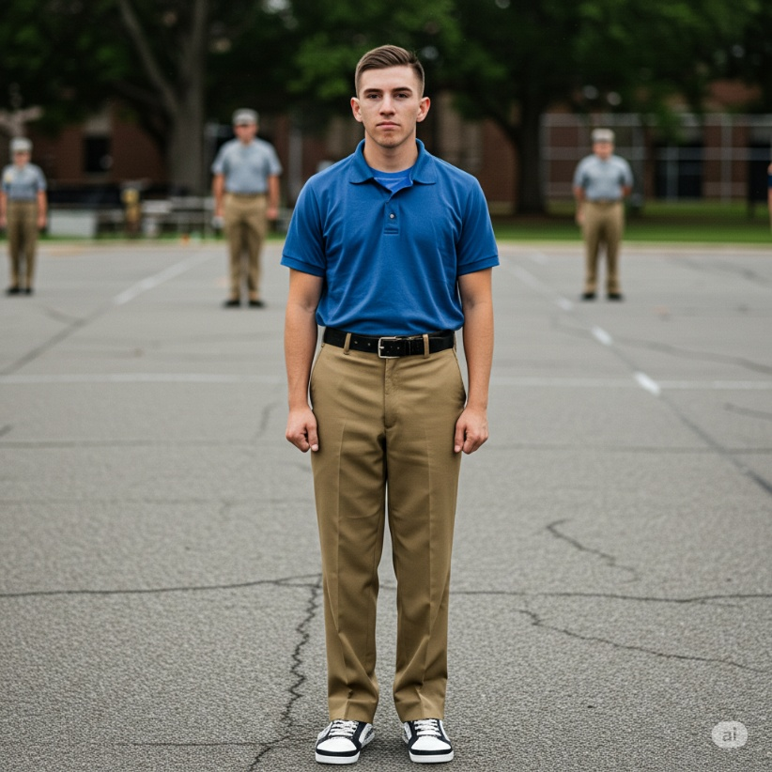

Room Essential Recommendations
-Dedicated plug in alarm clock (Your phone WILL fail you)
-Protein powder and a shaker bottle
-Planning Desk Calander for event tracking and critical times
-High Quality Shaving Razors (You will need to be clean shaven at every ROTC event)
-Hair clippers for last minute touch ups (Haircut regulations are in effect)
-Electrolyte powder

