CAPTAIN BEN K. SEXTON
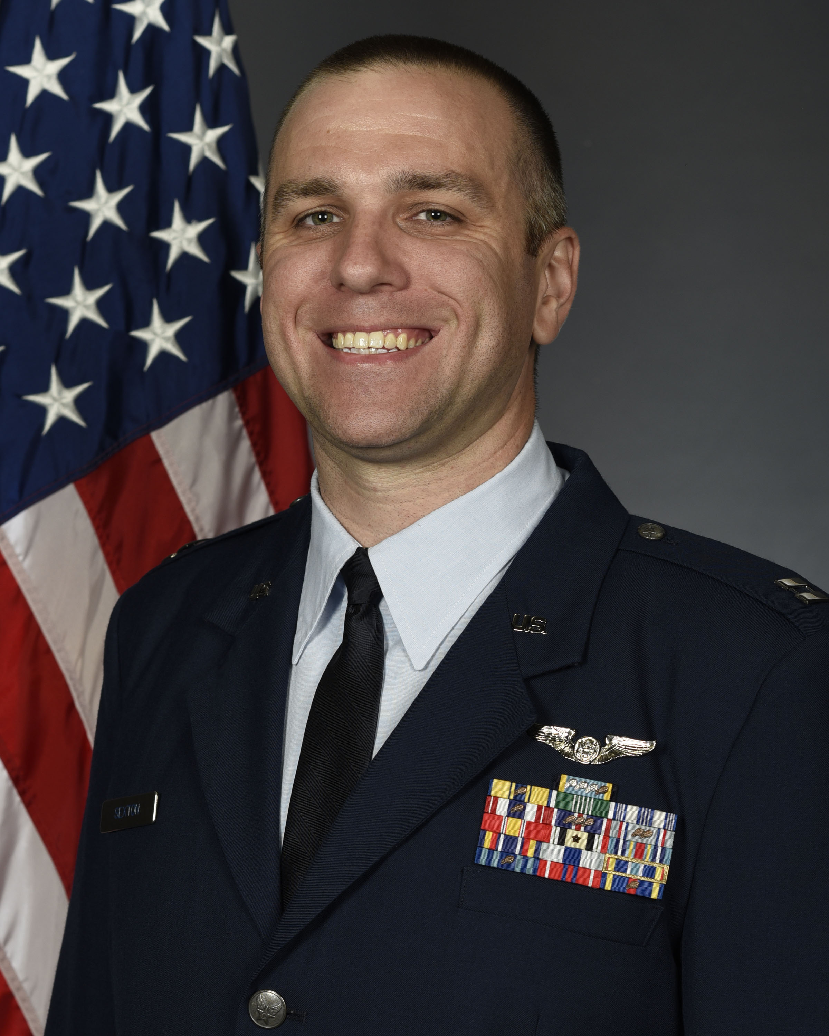
Captain Ben Sexton is the Education and Recruiting Officer of the Air Force Reserve Officer Training Corps, Detachment 905 at Washington State University and University of Idaho. He is responsible for leading, recruiting, training, counseling, and evaluating 100 highly qualified young men & women as prospective Department of the Air Force officers. Responsible for development, management, execution, and funding of all unit recruiting efforts. Promotes DAF career and scholarship opportunities to university staff, college & high school students, faculty, & parents. Instructs college curriculum covering Foundations of the DAF, DAF History, Leadership, & National Security Affairs.

Captain Sexton was born in Macon, GA. He entered the Air Force upon High School Graduation in 2007 as a Ground Radio Technician and later commissioned through Officer Training School as an Acquisitions Officer. He has deployed in support of Operation Iraqi Freedom and Operation New Dawn. Prior to his current position, Captain Sexton was the Deputy Weapons Section Chief, Robins AFB, GA.

EDUCATION
2007 Basic Military Training, Lackland AFB, TX
2007 Ground Radio Communications Basic Course Keesler, AFB
2011 Airman Leadership School, Luke AFB, AZ
2013 Basic Sensor Operator’s Course, Holloman AFB, NM
2014 Associate’s Degree, Space Technology, Community College of the Air Force
2014 Bachelor of Business Admin and Management, Grand Canyon University, Phoenix, AZ
2017 Officer Training School, Maxwell AFB, AL
2017 Acquisitions Officer Course, Wright-Patterson AFB, OH
2022 Squadron Officer School, Maxwell AFB, Al
2021 Master of Science, Project Management, Troy University, Troy, Al

ASSIGNMENTS
- February 2007-April 2007, Trainee, Lackland AFB
- April 2007-October 2007, Ground Radio Technician, Keesler AFB, MS
- November 2007-November 2010, Ground Radio Technician, 86 CS, Ramstein AB, Germany
- November 2010-June 2013, RF Transmissions Technician, 607 ACS, Luke AFB, AZ
- July 2013-April 2017, MQ-9 Sensor Operator, 17 ATKS, Creech AFB, NV
- April 2017-June 2017, Cadet, Maxwell AFB, AL
- June 2017-September 2017, LOGMOD Dep Program Manager, Maxwell-Gunter AFB, AL
- September 2017-June 2019, GFM-DI Dep Program Manager, Maxwell-Gunter AFB, AL
- June 2019-July 2020, Executive Officer, Maxwell-Gunter AFB, AL
- July 2020-June 2021 Aircraft Guns Program Manager, Robins AFB, GA
- June 2021-July 2022 Deputy Chief, Weapons Section, Robins AFB, GA
- July 2022– July 2023, Operations Flight Commander, Det 905, WA
- July 2023 – Present, Education and Recruiting Officer, Det 905, WA
MAJOR AWARDS AND DECORATIONS
Aerial Achievement Medal with 19 Oak Leaf Clusters
Air and Space Commendation Medal with 3 Oak Leaf Clusters
Army Commendation Medal
Air and Space Achievement Medal with 1 Oak Leaf Cluster
Meritorious Unit Award with 1 Oak Leaf Cluster
Air and Space Outstanding Unit Award with 3 Oak Leaf Clusters
National Defense Service Medal
Iraq Campaign Medal with 1 Service Star
Global War on Terrorism Expeditionary Medal
Global War on Terrorism Service Medal
Air and Space Overseas Service Ribbon Long
Air and Space Expeditionary Service Ribbon with Gold Border
Air and Space Longevity Service Award with 3 Oak Leaf Clusters
USAF NCO PME Graduate Ribbon
Air and Space Training Ribbon

EFFECTIVE DATES OF PROMOTION
Second Lieutenant June 16, 2017
First Lieutenant June 16, 2019
Captain June 16, 2021

(Current as of September 2023)

